 | SIMATS ENGINEERING  Department of Computer Science and Engineering
CSA15 Cloud Computing and Big Data Analytics
CO3 AT2 - Capstone Cloud Access and Service Integration Case Study Student Template
Course Code | CSA15 | Course Title | Cloud Computing and Big Data Analytics
Assessment | CO3 AT2 - Capstone Cloud Access and Service Integration Case Study | Submission Type | Individual digital case-study document
Faculty | Dr C. Rajesh Babu | Employee ID | SSETSCS415
Mode | Case study / capstone design reasoning | Submission | GitHub repository link through Google Classroom

How This Template Works
Read each case, connect it to the technical ideas learned in CO3 AT1, and then extend the design to your own capstone product. The answer must show cloud access, APIs, storage, serverless/event flow and edge/fog/cloud reasoning. Do not upload passwords, private keys, API tokens or sensitive personal data.

Student and Capstone Details
Student Name | K.Varshini
Register Number | 192472358
Class / Slot | Slot B
Capstone Title | SkillHire: AI Resume Screening and Job-Fit Android App
CO3 AT1 Evidence Link | https://github.com/varshinvarma1010/CSA1512/tree/9e2239eb9ff2514df4cf37e690c1f232847c42b0/CO3
GitHub Repository Link | https://github.com/varshinvarma1010/CSA1512.git
Submission Date | 07-08-2026

Case 1: Cloud-Native Backend and Web API Architecture
Scenario
A food delivery company wants to deploy a cloud-native backend with web APIs, browser/mobile clients and shared cloud storage for receipts and delivery images. Design the architecture and explain the role of each component.

A. Case Architecture Diagram
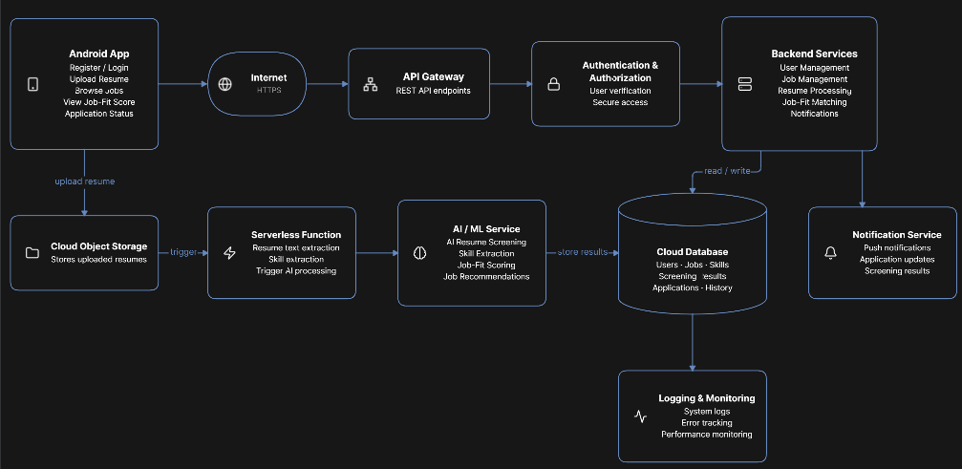

B. Component Role Explanation
Component | Role in Skill Hire
Browser/Mobile Client | Allows job seekers and recruiters to access Skill Hire.
Hosted Frontend | Provides the user interface for registration, login, job search and applications.
REST API | Transfers requests and responses between the frontend and backend.
Authentication | Verifies users before allowing access to protected features.
Backend | Processes job posting, searching, applications, profiles and skill information.
Cloud Database | Stores user details, job information, skills, applications and hiring history.
Object Storage | Stores resumes, certificates and other uploaded documents.
Serverless Functions | Executes specific tasks such as processing uploads and sending notifications without maintaining a dedicated server.
Logs and Monitoring | Records system activities and helps identify errors and performance problems.

C. Capstone Extension: user-to-cloud workflow for your product
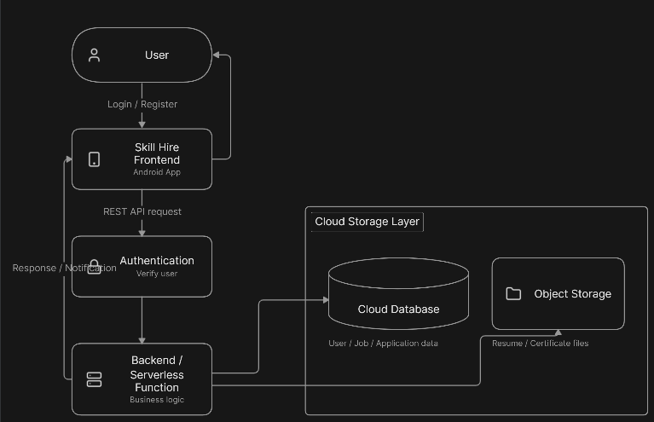

Case 2: Storage and Serverless Upload Workflow
Scenario
A media startup must decide between SAN-backed storage, object storage and serverless processing for upload workflows. Recommend a deployment model and justify it.
Data / Event | Best Storage | Serverless Action | Reason
User profile | Cloud Database | Update profile function | Frequently accessed structured data
Job details | Cloud Database | Job management function | Structured and searchable information
Resume | Object Storage | Resume upload function | Suitable for files and documents
Certificate | Object Storage | Certificate upload function | Handles document storage efficiently

A. Storage and Serverless Recommendation
For Skill Hire, cloud database + object storage + serverless processing is recommended.
The cloud database stores structured information such as users, jobs, skills and applications. Object storage is used for resumes and certificates because these are file-based data. Serverless functions can automatically process uploaded files and perform background operations.
This architecture reduces the need to continuously maintain dedicated servers and can scale according to the number of users and requests.


B. Failure Handling and Cost/Performance Explanation

Failure Handling
- If an upload fails, the system displays an error message to the user.
- Invalid file types can be rejected before storage.
- Database failures can be recorded in logs.
- Serverless functions can retry suitable failed operations.
- Monitoring helps identify repeated failures.
- Important user data should be backed up.

Cost and Performance
Object storage is suitable because Skill Hire may contain many resumes and certificates. Serverless processing can reduce cost because resources are used when functions are executed. Cloud services also allow the application to handle increasing users without manually increasing physical server capacity.

C. Capstone Extension: one upload/event workflow
A job seeker uploads a resume through Skill Hire. The frontend sends the upload request to the backend. The resume is stored in object storage. This generates an upload event, which activates a serverless function. The function validates and processes the file and stores the resume reference in the database. The user then receives a successful upload response.

Case 3: Edge, Fog and Cloud Placement
Scenario
A smart-city platform needs low-latency decision-making near sensors while still using the cloud for analytics. Decide what runs at edge, fog and cloud.
Task | Layer | Latency Need | Data Volume | Reason
User input validation | Edge | High | Low | Quick response to users
Basic application checks | Edge | High | Low | Reduces unnecessary network requests
API request processing | Fog | Medium | Medium | Provides faster intermediate processing

A. Edge/Fog/Cloud Architecture Explanation
Edge Layer:
The edge layer handles simple operations close to the user, such as input validation and basic checks. This can reduce unnecessary communication with the cloud.
Fog Layer:
The fog layer can handle intermediate operations such as API request processing, authentication and request routing.
Cloud Layer:
The cloud handles resource-intensive and centralized operations such as job matching, recommendations, database storage, resume storage, analytics and reports.

B. Capstone Extension or Direct Cloud Access Justification
Skill Hire mainly uses cloud-based processing because the application needs centralized access to job postings, user profiles, skills, applications and uploaded documents.
Cloud access provides scalability, centralized storage and availability. Job seekers and recruiters can access the platform from different locations through the internet.
Edge processing can be used for simple validation, while intermediate API processing can be handled through a fog layer when required. The major processing and storage operations remain in the cloud.

Final Capstone Cloud Access Architecture
☐ Show Browser/Mobile Client.
☐ Show hosted frontend or app access path.
☐ Show REST API endpoint and authentication check.
☐ Show backend/serverless logic.
☐ Show database, object/blob storage, logs and monitoring.
☐ Label the arrows: request, response, upload, event, notification or monitoring signal.

Final Diagram and Explanation
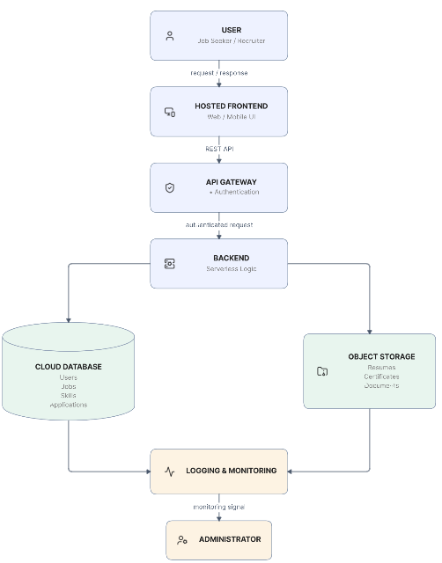
Skill Hire is designed as a cloud-based hiring platform connecting job seekers and recruiters. Users access the system through a hosted web or mobile frontend. Requests are sent to REST APIs, where authentication is performed before the backend processes the request.
The backend communicates with the cloud database to manage structured information such as user profiles, jobs, skills and applications. Resumes and certificates are stored separately using object storage. Serverless functions can respond to events such as document uploads and perform background processing.
Logging and monitoring are included to track system performance and identify errors. This architecture provides centralized cloud access, scalable storage and efficient processing for the Skill Hire platform.

Submission Checklist
✅☐ Template completed in DOCX format.
✅☐ Diagrams pasted clearly in the document.
✅☐ GitHub repository contains DOCX/PDF, diagrams and README.
✅☐ Google Classroom submission contains GitHub link.
✅☐ Sensitive credentials are not visible anywhere.

Student Assurance
Declaration
I confirm that this case-study answer, cloud access design, diagrams and capstone extensions were prepared individually by me for the stated capstone title.
Student Signature: __K.varshini__________________ Date: ______07-08-2026_____________

